[Document subtitle]

**10 watt audio amplifier**

**عمل الطلاب: -**

**احمد زكريا عبد العال يوسف**

**يحيي محمد محي محمد**

**إسلام محمود توفيق**

**احمد محمد محمود**

**احمد فتحي عواد**

**رمزي احمد رمزي**

**اشرف محمد ابراهيم**

**ممدوح السيد احمد**

**بهاء أحمد عزب**

**اسلام أسامة فاروق**

**مادة الكترونيات 2**

**م:-معتصم قطب**

**د:-مصطفى الطوخي**

**Equipment: -**

**1-TDA2003 audio amplifier IC**

**2-220 ohm 5w resistor**

**3-2.2 ohm 0.25w resistor**

**4-39 ohm 0.25w**

**5-1.2 ohm 0.25w resistor**

**6-Adaptor 300ma 12 volt**

**7-1000uf 50v capacitor**

**8-470uf 50v capacitor**

**9-100uf 50v capacitor**

**10-10 uf 50 v**

**11-39nf 100v capacitor**

**12- 100nf 100v capacitor**

**13- 100nf 100v capacitor**

**14-Speaker**

**15-audio input**

**Circuit connection: -**

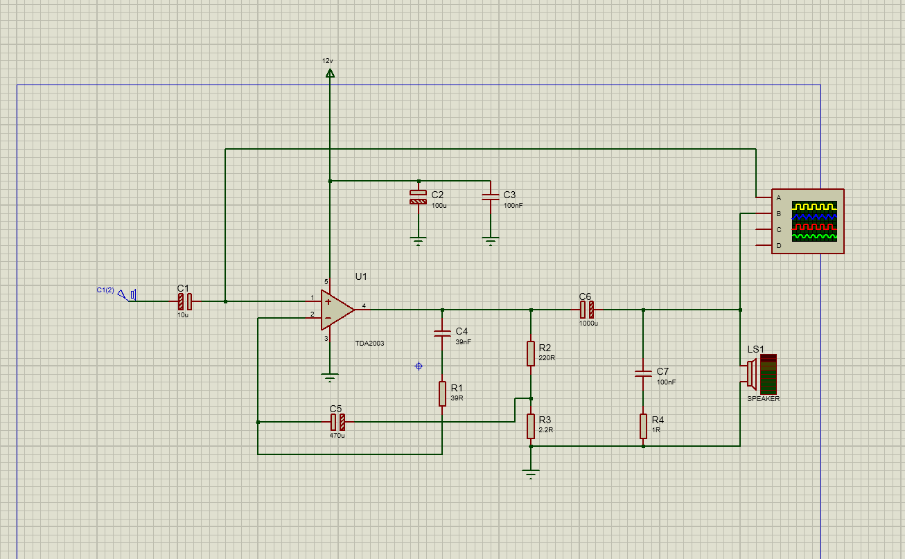

**TDA2003 EXPLAIN**

**1- internal design with explain how it works:**

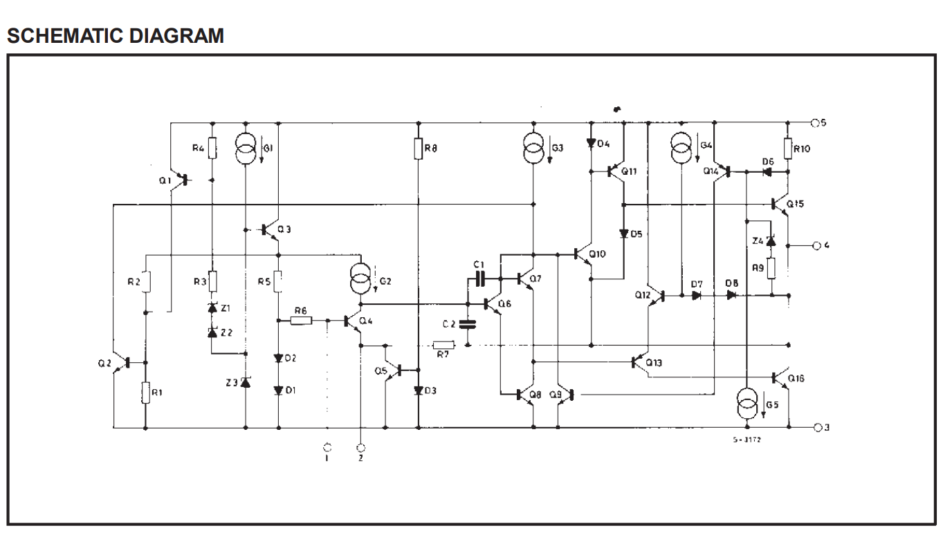

**DESCRIPTION**

**The TDA 2003 hasimproved performancewith the same pin configuration as the TDA 2002. The additional features of TDA 2002, very low numberof externalcomponents,ease of assembly, space and cost saving, are maintained. Thedeviceprovidesa high outputcurrentcapability (up to 3.5A) very low harmonic and cross-over distortion. Completely safe operation is guaranteed due to protectionagainst DCand ACshort circuit between all pins and ground,thermal over-range,load dump voltage surge up to 40V and fortuitous open ground.**

**How It Works?**

The TDA2003 amplifies a weak audio signal through a series of internal stages. Here's a simplified explanation of what happens inside the chip:

1. **Preamplification:** The faint audio signal from your car radio enters the TDA2003. This initial stage slightly amplifies the signal to prepare it for further processing.
2. **Differential Amplification:** The signal is then fed into a differential amplifier circuit. This circuit amplifies the difference between the positive and negative halves of the audio waveform, essentially removing any DC offset and making the signal stronger.
3. **Voltage Amplification:** The core of the amplification stage is a series of voltage gain stages. These stages use transistors to significantly increase the voltage of the audio signal, making it much stronger.
4. **Output Stage:** The amplified signal is then sent to the output stage. This stage consists of power transistors that can handle the higher current needed to drive your car speakers. The output stage converts the amplified voltage signal back into a current signal suitable for powering the speakers and reproducing the sound.
5. **Protection Circuits:** Throughout this process, various protection circuits monitor the TDA2003's operation. If any issues like overheating or short circuits arise, these safeguards kick in to prevent damage to the chip.

It's important to note that this is a simplified explanation, and the actual workings involve complex electronic principles.

If you'd like to delve deeper, you can find resources online that explore the specific transistor configurations and biasing techniques used within the TDA2003. However, this simplified explanation should give you a general idea of how the TDA2003 takes a weak audio signal and boosts it to power your car speakers.

**SIMULATION:-**

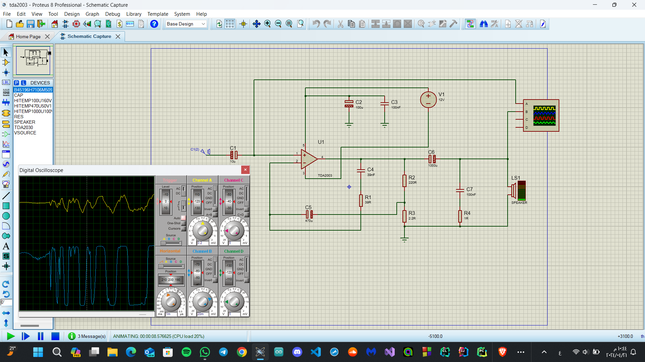

**Overview: -**

**the TDA2003 IC. This IC is commonly used for audio amplification and can be found in stereo or mono audio design circuits. Here’s how it works and the role of each component:**

**TDA2003 IC Overview:**

**The TDA2003 is a 5-pin audio amplifier IC.**

**Pin 5 and 3 are used to power the amplifier IC.**

**The audio signal to be amplified is given through pin 1 (the non-inverting input).**

**The amplified audio output can be obtained through pin 4.**

**Hardware Components:**

**TDA2003 IC: The heart of the circuit, responsible for amplifying the audio signal.**

**Loudspeaker (Speaker): The output device that produces sound.**

**Potentiometer (Volume Control): Adjusts the gain or volume of the amplifier.**

**Capacitors (C1, C2, C3):**

**C1 : Blocks any DC signal from the input, allowing only the AC component to reach the amplifier.**

**C2 (Filtering Capacitor): Filters out residual noise from the IC output signal.**

**C3 (Feedback Capacitor): Part of the feedback path for stability.**

**Resistors (R1, R2):**

**R1: Determines the upper cutoff frequency.**

**R2: Part of the feedback network for stability.**

**Battery (12V): Provides power to the circuit.**

**Soldering Iron and Wire: Used for assembly.**

**Circuit Working Explanation:**

**Audio Input:**

**The audio input signal (from a smartphone or other source) is connected to the non-inverting pin of the TDA2003 IC.**

**Capacitor C1  blocks any DC component, allowing only the AC audio signal to reach the amplifier.**

**Amplification:**

**The TDA2003 IC amplifies the AC audio signal.**

**The inverting input (connected to the feedback network) stabilizes the amplifier.**

**Filtering:**

**The output from the TDA2003 IC passes through filtering capacitor C2 to remove residual noise.**

**Output:**

**The amplified audio signal can be taken to any loudspeaker with an appropriate resistance.**

**If the speaker output is noisy, a  film capacitor can be connected for stability.**

**Application:**

**TDA2003 amplifiers are commonly used in:**

**Car audio systems**

**Electronic audio instruments**

**Public addressing systems**

**Resistors Functions: -**

**In a TDA2003 amplifier circuit, resistors serve several important functions:**

**1-Input Signal Level Control: Resistors are used to reduce the input voltage to a suitable level that the amplifier can handle without distortion.**

**2-Gain Setting: Resistors determine the amplification factor (gain) of the circuit, affecting how much the input signal is amplified.**

**3-Frequency Response Control: Resistors, in conjunction with capacitors, form filtering circuits that influence the circuit’s response to different frequencies.**

**4-Circuit Protection: Resistors help protect the circuit from excessive currents that could damage other components.**